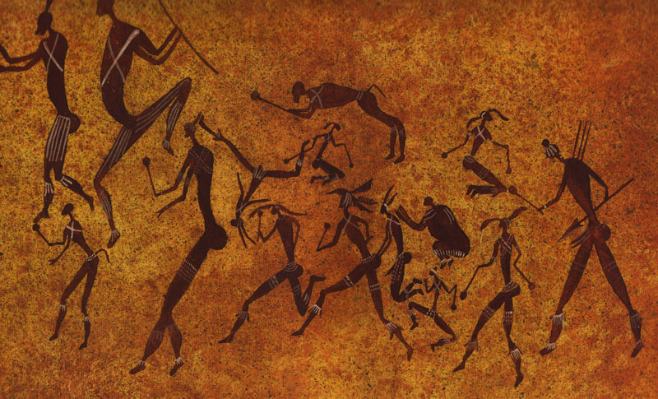
African Board Game Sagas
eatondo

Agent name: eatondo

Forward

Forward to the reader
eatondo
address
(123) 456-7890
liidia@example.com
www.interestingsite.com

Table of Contents
Game i — AfRICAN DIETIES 1
Game II — King and seven sons 3
How Terramare got its Name 3
Terramare of Montale 3
Game IIi — tales of siloan 4
Game IV — tales of obatala 5
Game V — lila vs fila 6
Game VI — the boy hunter 7
Game vII — king gumbi and the lost daughter 8
Game VIII — tortoise tales 9
Game IX — queen of the pool 10
Game x — cattle and snake tales 11
Game xI — akim and the jealous seven 12
Game xIi — bonus game 13

Game i — AfRICAN DIETIES and Lore
The chapter title is intended to start approximately one-third the way down the page. The spacing is built into the Heading 1 style. To ensure spacing is correct, insert a Next Page Section Break at the end of each chapter prior to beginning a new chapter. To do that, go to the Layout ribbon, choose “Breaks,” and select “Next Page” under the “Section Breaks” section of the menu.
[Opening Paragraph]
Click on “Opening Paragraph” above and start typing your book. This is the opening paragraph of your chapter and is hence without indentation. Introduce your story and set the stage for the rest of the novel. Ensure that the first few lines of the introductory paragraph and the first few paragraphs of the chapter hook the readers’ interest. The more visual your writing is, the better.
Use the style called “Normal” for the Opening Paragraph.
[Next Body Paragraph]
Being a new paragraph, this one will be indented on the first line. This makes it easy for the reader to see a new paragraph among blocks of text. This is not a new scene, however! New scene beginnings are not indented and will follow the hash (#) sign.
The second and subsequent paragraphs of each chapter will begin with a first line indent. This is built into the style called “Normal Indent.”
- Begin every new chapter from a new page.
- Do not add any extra spaces between paragraphs. All lines are double-spaced. The format of double spacing is built into both Normal styles.
- After all punctuation, only use a single space before starting the next sentence.
- Do not underline in your manuscript. However, you may italicize things.
#

[New Scene begins without indentation]
The first paragraph of each new scene or chapter should begin with the style “Normal.”
[New Scene’s second paragraph.]
Remember that all new paragraphs, as well as dialogue, needs to be indented. These will also use the style called “Normal Indent.”
Since your novel will have several chapters, ensure that you leave enough motivation at the end of each chapter for the reader to continue with the next.
[New Scene’s third paragraph.]

Game II — King and seven sons

How Terramare got its Name
When using a subheading, be sure to use at least two.
[Opening Paragraph]
[Next Body Paragraph]
[Next Body Paragraph]

Expansion: 7 daighters
[Opening Paragraph]
[Next Body Paragraph]
[Next Body Paragraph]

Game IIi — tales of siloan vb
[Opening Paragraph]
[Next Body Paragraph]
[Next Body Paragraph]

Game IV — tales of obatala
[Opening Paragraph]
[Next Body Paragraph]
[Next Body Paragraph]

Game V — lila vs fila
[Opening Paragraph]
[Next Body Paragraph]
[Next Body Paragraph]

Game VI — the boy hunter
[Opening Paragraph]
[Next Body Paragraph]
[Next Body Paragraph]

Game vII — king gumbi and the lost daughter
[Opening Paragraph]
[Next Body Paragraph]
[Next Body Paragraph]

Game VIII — tortoise tales
[Opening Paragraph]
[Next Body Paragraph]
[Next Body Paragraph]

Game IX — queen of the pool
[Opening Paragraph]
[Next Body Paragraph]
[Next Body Paragraph]

Game x — cattle and snake tales
[Opening Paragraph]
[Next Body Paragraph]
[Next Body Paragraph]

Game xI — akim and the jealous seven
[Opening Paragraph]
[Next Body Paragraph]
[Next Body Paragraph]

Game xIi — bonus game
[Opening Paragraph]
[Next Body Paragraph]
[Next Body Paragraph]

Closing remarks
[This is the last line of your manuscript]
THE END
This marks the end of the manuscript and will follow a double-spaced blank line after the last line of text.

